California State University of Monterey Bay

The Most Dearly Beloved
Gottardo Piazzoni

Shelby Lydon
VPA 313: Regional Art History
Susan Leask
5 October 2014
Switzerland born Gottardo Fidele Ponziano Piazzoni came to California in 1887 at the age of 15 following his father who had established land in the auspicious Carmel Valley. Before long, the Monterey landscape around his home became a stirring point, and later pinnacle subject during his nascency as an artist; it would be in these landscapes that he would discover himself as a tonalist painter and muralist. Simultaneously, an influx of Chinese, Japanese, and Filipino immigrants generated the Asian movement to California; and with the increase in immigrants, Oriental influences on art and culture were introduced and stirred into the “Melting Pot” of California. As his art matured, despite having made no direct contact with Eastern Asian countries, Gottardo Piazzoni demonstrated a remarkably similar art-style throughout his career as a painter, one which embodied his perception and admiration of the natural landscapes of California.
All styles of art deviate and are constantly changing, preserving the old and giving life to the new. Eastern and Western art styles have followed this convention of change and preservation, making identification of the classification and properties of Eastern and Western styles perceptible. Art that is based in Japan, not especially ink but all art, incorporates a spirit and a connection with nature and the natural world. There is an air of emptiness with control, melancholy and peaceful; there is zen and tranquility in the art. Paintings using ink in Eastern Art are made with very quick, smooth brush-strokes, usually with varying muted colors or sometimes only with black and white hues. Arvydas Liogeris writes in his book The Thing and Art: Two Essays on the Ontotopy of the Work of Art, “...there can not be any corrections or refinements, for the moment does not repeat itself...to capture the configuration of a moment, one must paint in a flash” ( pg 110). He, Liogeris, uses Hokusai’s painting of Fuji as an example illustrating that Hokusai does not paint the illustrious mountain itself, but the view of it, as it is a decoration of the scenery, a “non-substantial form”. Traditional Chinese and Japanese art retains a similar idea of background and linear perspectives.
Asian art, due to the incorporation of nature, displays a great deal of landscapes and perspectives that remain simple, almost flat and yet still very conscious of detail and lines. Traditional Japanese art especially is very conscious of the natural world. Piazzoni exhibits similar traits in his own landscapes and murals using very subdued and muted colors that sometimes almost bleed together in his paintings. In an examination by Scott Shields regarding Piazzoni’s motives and influences, he points out that Piazzoni uses flat shapes and patterns which were used similarly by Japanese artists. Piazzoni’s daughter reflects on her father’s life saying, “[Piazzoni] appreciated everything about nature” (Shields 109). Gottardo Piazzoni expressed deep feelings in his paintings comparable to literature and poetry, there is rhythm in the strokes and direction of lines. Much like Eastern art, Piazzoni captures the sense of serenity in the hills and mountains of California, the calm of the beaches and the brightness of the sky and sunlight for which it is idolized.
In San Francisco, Piazzoni’s style appealed to conservatives and modernists and he became recognized by his community as an outstanding artist and genuine man. Due to his academic background, having attended art school in Paris and at the California Institute of Design in San Francisco, Piazzoni was incredibly educated in different styles of art and became an important figure among the San Francisco domain, described as “the most beloved member [of the art community]” (Sheilds 108). Between 1932 and 1945, Piazzoni painted a series of fourteen murals for the San Francisco Public Library called “The Land” and “The Sea” which depicted the hills of the California Coast. Using very closed tones and hyper-simplification, Piazzoni uses a solitary line almost like a guide to seperate the earth from the sky, something that is present in Eastern art as well. Since revived, the mural remains one of his most well known series of paintings and is currently displayed in the De Young Memorial Museum in San Francisco. (Marter, pg 117)
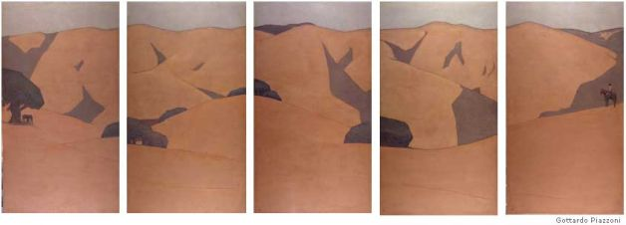
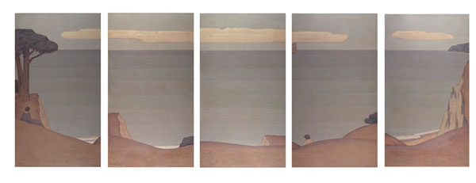
Another possible indication that Piazzoni was influenced by Eastern art styles is his attachment to the tonalist style of painting, rather than the up and coming futurism movement that was growing in Europe and making its way to the West. Futurism, in opposition to tonalist art, focuses on unnatural elements of the future, such as machinery, and is painted in a way that elicits motion. Often very bright, colorful pieces that pull an audience into the fast-paced illustration, Tonalism, alongside generous amounts of East Asian art, does not invite onlookers to move but rather to remain still. The simplified and subdued colors of a Tonalist piece of work like Piazzoni’s expresses his favor and loyalty to the past rather than the movement and exuberance of the future. This does not mean, however, that he was opposed to the oncoming of futurism, on the contrary, he embraced any art movement that “[made] for the advancement of art and the development of individuality...Especially I am interested in Futurism” (Shields pg 108). Many Eastern art pieces also eliminate any if not all hints of human presence in most landscape paintings. This is obviously opposite of the futurist movement, which suggests a great involvement of human creation to bring forth the future. (Nash, pgs 40-43; Selz, pg 99; Shields pgs 107-108)
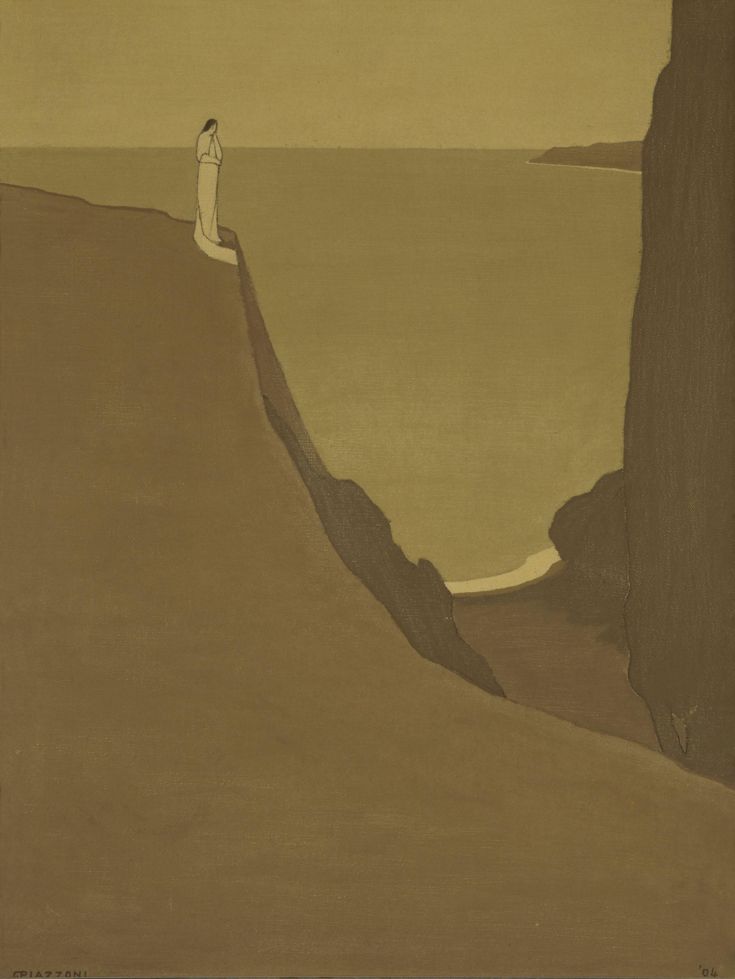
If there is the aura of human existence found in some of Piazzoni’s art, the figures take on a very Eastern-style presence of simplicity and modesty. For instance, the painting titled Reflections, an oil on canvas painting which Piazzoni completed in 1904 has an extremely Asian atmospheric quality. In Piazzoni’s painting, colors follow his typical simplified style, with no real distinction between them except for light and dark. At the same time, no part of the paint used becomes entirely black, something that is commonly found in Tonalist pieces. The robed figure stands atop a cliff any real identification of sex is masked by the robe; the figure is still as she overlooks the sea from the cliff side, covered only in a white robe. The message of the painting is not clear, however Piazzoni demonstrated in a variety of paintings, as well as interviews, that his art was more often symbolic rather than literal and so is open to many interpretations. It is widely accepted in Chinese and Japanese culture that the color white represents death, and so perhaps the figure in Piazzoni’s painting is a ghost, or someone who is contemplating death or is somehow affected by death. Cliff and mountainous landscapes are often depicted in a variety of Eastern art as well; the mountains and coastline of California no doubt offered Piazzoni an opportunity to recreate similar landscapes of his own.
Swiss-Italian Tonalist painter Gottardo Fidele Ponziano Piazzoni grew up to become an influential part of the California central coast art culture in the late 1890’s and early 1900’s. Using an assortment of natural pigments and a soft-spoken personality, Piazzoni painted an assortment of murals and landscapes using simple and demure hues in order to create poetic scenes of his beloved California. His style, which seemed to manifest a resemblance to Eastern art, such as from China or Japan, incorporated a sense of spirit and reverence for nature rather than obscuring it with an abundance of unnatural components. This is likely due to his position in California and proximity to the increase in Eastern immigrants to the area during the time of his development as a serious artist and figurehead in the art community. It is the similarity in style and in quiescent thinking that Piazzoni embraces a style of art in which he is recognized while simultaneously reflecting the consciousness and ingenuity of a culture far beyond him. Artist Russell Chatham recalls of his grandfather, “...it is the underlying spirit or elemental force of Nature that [Piazzoni’s] pictures reveal, its vastness, its silent voice, and above all its perfect peace.”

Resources:
Holloway, Jan. "The Piazzoni Legacy Three Generations Paint the Splendors of California." Bolinas Museum. 30 Apr. 2005. Web. 4 Oct. 2014. <http://www.bolinasmuseum.org/exhibition10048.html>.
Liogeris, Arvydas. The Thing and Art Two Essays on the Ontotopy of the Work of Art. Amsterdam: Rodopi, 2009. Print.
Marter, Joan M. The Grove Encyclopedia of American Art. Vol. 1. Oxford: Oxford UP, 2011. Print.
Nash, Steven A., and Bill Berkson. Facing Eden: 100 Years of Landscape Art in the Bay Area. San Francisco: Fine Arts Museums of San Francisco; 1995. Print.
Oakland Meuseum of Art. Web. 7 Oct. 2014
http://collections.museumca.org/?q=category/description/oil-canvas
Scott A. Shields. Eternal Light: Visions of Gottardo Piazzoni. California History, Vol. 80, No. 2/3 (Summer - Fall, 2001), pp. 106-123
Selz, Peter. "Impact From Abroad." On the Edge of America: California Modernist Art, 1900-1950. Ed. Paul J. Karlstrom. Berkeley: U of California, 1996. Print.

