The Makings of a Movement

Shelby Lydon

Regional Art History 313
- Leask
December 5th, 2014

“Feminist Art is not art made by women”, as stated by Kathleen Desmond, author of Ideas about Art. Judy Chicago, internationally recognized feminist art philanthropist, says of feminist art, “[feminist art] is art that reaches out and affirms women and validates our experiences…” The Feminist Art Movement reflects an almost unrecognized piece of history in which female artists were able to illustrate, demonstrate, and orchestrate a predominantly female expression through the arts. In a male-dominated creative culture, female artists rose beyond their designated statures to release a barrage of passionate narratives, installations of femininity and sexuality, and bare themselves to a world which has tried to shut them out. One such artist, a California local named Rose Sellery, uses free expression and a non-combative representation of sexuality in her artwork to put female and male sexualities on level ground, leaving no one untouched by her story. (Desmond 2011, Brodsky 2008, Chicago, nd)
Female artists creating work during the 1960’s and 70’s found themselves creating “Feminist Art” whether or not it was their true intention. Even today, many art critics and historians identify an artwork and categorize it based on the sex of the artist who had created it; thus, if you are female, you have just created feminist art. (Desmond 2011) Unlike most pieces of art created by men, Feminist art is meant to be recognized by its content, content which is specific to women who exist in a world run by men. This different adaptation of experience and expression is what separates the female sensitivity from the male desensitised creation. (Tuana 2006) Judy Chicago writes in her application that feminist art is meant to caress and not conquer, and that dominating a surface such as with most male-created paintings is too aggressive; this is the type of art she does not want to create. “[The canvas] was to be discovered, not manipulated; nourished, not controlled,” (Chicago, nd)
Recognizable traits of feminist art come not only with expressions and experiences, but with physical forms as well. Many pieces of art created in a feminist style contain motifs of sexual imagery, for instance womb-centered imagery and central core imagery. In Womanspace Journal, a list of female characteristics in art was written which includes “a uniform density, an overall texture, often repetitive to the point of obsession . . . layers or strata, and a new fondness for the pinks and pastels…” (Chadwick 2011) Vaginal references are also often made because of its significance to the identification of the female sex. What makes feminist art different from non-feminist art is that most artworks representing the female sex, created over the course of thousands of years, were in fact created by men, the very opposite of what it is to be a woman. In many situations, female artists adapted alternative media that did not carry a male affinity, for instance the use of fabric, video media, and performance art; the use of new materials caused a ripple in the artistic scene where women were the only masters. Although society recognizes the differences between female and male lifestyles and experiences, this freely allows men to assume the dominant role in defining what the true depiction and placement of a woman is. That is not to say that men cannot also create feminist art, but what remains to be true is that feminist art created by females is considered “a unique expression of personal experiences and firsthand knowledge…” (Tuana 2006) Many female artists use narratives, or storytelling, to create or recreate their personal experiences. “The ways that sexual difference is produced through representations, and through the stories that reinforce them, were central to the work of many women active in a social movement…through consciousness-raising techniques that stressed storytelling,” Chadwick clarifies. (Desmond 2001, Chadwick 2008, Tuana 2006, Brodsky 2008)
Due to the incredible number of recognized male artists and the minority of female artists, the latter remains overlooked and ignored in the professional world, not just the art world. The questions many female artists are faced with is: how can a man, however empathetic he may be, accurately depict a circumstance in a female’s life that I, a female, can not create more truthfully, and secondly, why am I, the very person this pertains to, considered unable to create such artwork that is considered at the same level of credibility and recognition by society? As Hypatia dictates, the male artists paints a stereotype of women; women are rarely sexual, passive, and dependent. This is the patriarchy, the very idea that women who are made to live a shadowed, sheltered life, are forced to accept. That is until the moment women became unafraid and spoke up in the 1960’s, during a time of sexual redefinition, that which is now historically recognized as the Feminist Art Movement. (Tuana 2006)
The Feminist Art Movement reached women everywhere, even across oceans. In 1970, women in North America, specifically in California and New York, along with Great Britain began to protest inequality in museums for lack of female artist inclusion and representation. In 1970, the Los Angeles Council of Women Artists gathered and demanded an “Educational Program for the Study of Women’s Art.” That same year, Judy Chicago taught the first feminist art course at Fresno State College. A journal written by Chicago and fellow artist Mariam Schapiro titled Womanspace Journal began to question what it was that society dictated made a woman. In the article they wrote, “What does it feel like to be a woman? To be formed around a central core and have a secret place which can be entered and which is also a passageway from which life emerges?” (Chadwick 2008)
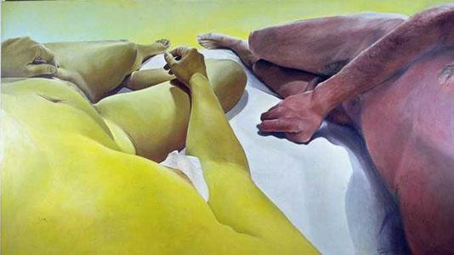
What is exceptional about the Feminist Art Movement was that it was not just exclusive to women, but to all everyone. As a whole, the movement was a collaboration between philosophers, teachers, scientists, housewives, artists, and anyone else that breathed the same idea of fighting the patriarchy. (Tuana 2006) The movement played a large role in bringing lesbian, gay, and other gender minorities into the artistic circle in order to challenge the concept of heteronormativity. Racial inequality was also outwardly challenged by the feminist movement, races of people living in the United States specifically. For instance, an artist named Joan Semmel completed an oil on canvas piece in 1974 titled Antonio and I, which includes the figure of a yellow-toned woman and a darker-skinned man lying naked next to each other. The remarkable aspect of this painting is exactly what makes it definitively feminist; Semmel has not only used her own body as the model, but has created the image in the first person perspective, as you would see it if you were one of these two people. What makes feminist art so passionate and inclusive is that you are welcomed, and in fact encouraged to become a part of it and share in the experience, just like in the painting above. Here is a prime example of the difference between male and female artistry; it is very likely that a man with a similar concept might draw these to figures from a third person perspective, watching from an outer perspective rather than being able to imagine himself in the position of the character painted. Feminist art is all about the idea of perspective. (Fuller 2002)
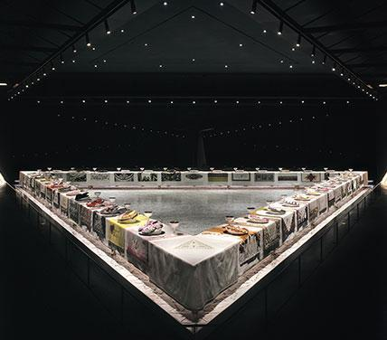
One artist that was previously mentioned whom had a significant role in the creation and development of the movement was Judy Chicago. Among Chicago’s work, . The Dinner Party, created between 1974 and 1979, is one that she is still being recognized for. Feminist art has seen many mediums, paint, photography, performance, and the like; however, the theme of this study centers on the idea of two: the narrative and installation. The Dinner Party, 2002 is a monumental design of installation creation, speaking volumes about feminine action and credibility previously unheard of or unnoticed by society. What the piece is is a representation of the roles of important female women, real people and fictional characters alike, who were either undervalued by society despite their great achievements, and or were in fact adored and worshipped, as is the case of the goddesses included. Atop a triangular stone table are the place-settings and names of 39 influential women of history, among them Susan B. Anthony and the Egyptian goddess Ishtar. Everything about the installation is thought out, including the shape of the table; it was not made a triangle on accident. The shape of a triangle is actually a very early symbol of both the female and of the goddess; Chicago made the table, as well as the porcelain floor into this shape in order to emphasis her belief in teaching equality. Among the piece is a similar theme which is recognized in many feminist works of art; Chicago uses genital imagery, china plates carved with images of vulva or butterflies. (Fuller 2002, Chadwick 2008, Chicago, nd, Gerhard 2013)
With The Dinner Party, the circulation of feminist style comes full circle; Judy Chicago did not complete this installation by herself, it was in fact quite the opposite. Once again, it is the inclusion in all people that makes feminist art so substantial, and for her piece, Chicago recognizes all of the men and women who helped her to complete her vision, totally around 400 over the course of 5 years. However, the display of her completed product did not come without struggle, in fact it was incredibly difficult to have. The Dinner Party, 2002 available to show professionally. Chicago received criticism for displaying “obscene” imagery because at the time rendering of the female form was considered unfamiliar, and therefore shocking to society. In addition, her lack of a professional title in the art scene presented many obstacles to her and her collaborators. This is one more example of the struggle women faced when presenting their art to the world. (Gerhard 2013)
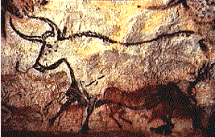
A great number of female and male artists alike create physical, dimensional art referred to as installation art. The origins of installation art go far beyond our modern scope of contemporary, reaching far into our past to the Paleolithic era, almost three million years ago. Although different from our recently developed version, the murals painted on cave walls by our distant ancestors marked the beginning of the physical manifestation of art. What makes these paintings an adaptation of installation is that they were painted using natural pigments and on the immovable surface of the cave; textured and rocky, the paintings of wild animals flow with the grain and was permanently woven into natural architecture. (Davies, 1997)
By definition, more contemporary installation art is “art that is created, constructed, or installed on the site where it is exhibited, often incorporating materials or physical features on the site” (Dictionary. com) Much like the painting above, featured in the Lascaux cave in France, as well as Judy Chicago’s. The Dinner Party, 2002, all installation work is deeply involved in the environment they are displayed in, whether that be site-specific, permanent, or moveable pieces. Installation art is far different than the portable framed-painting; Egyptian tombs, temples in Greece and other creations all relate to architecture, of the physical creation that can not only be observational but also interactive. Installation is closely tied to the experience of the audience members when they are introduced to a series or exhibition, and how their interaction with the environment is key to their own experience and interpretations. It is a personal experience when you step into the space containing an installation and as an audience, are invited to become a part of the environment and experience its story firsthand. (Bishop 2005, Oliveira 1994, Reiss 1999)
Rose Sellery, another female artist and active participant in the Feminist Art Movement, is one who creates a wide variety of art from wearable to installation. The materials Sellery has used also vary greatly, from ornate metal jewelry, to dresses and boats made of bones. Born in Venice, California, Sellery instead grew up in Los Angeles, her parents owned a large ceramic manufacturing company in the LA area creating high-fire stoneware ceramics; because her parents had both studied ceramic work at University California Los Angeles, they provided a unique artistic perception and opportunity to Rose and her siblings. Rose mentioned that her and her siblings often went to art openings and were given art books at very young ages. (Rose Sellery interview 2014)
Rose Sellery first became active in the art world after her own child had grown and become independent from her. Due to her previous knowledge working with ceramics and doing woodwork, Sellery returned to school at California State University of Long Beach to pursue her own artistic passion by studying jewelry and welding. However, while her wearable creations brought her success, they seemed to lack a story and expression which she later discovered through her sculptural work. For instance, the piece featured above titled Overeaters Anonymous Utensils is a piece she created using iron metallic paint, seed pods, leaves, and flower stems. The incredibly fragile utensils made of flower stems reflect the woman, weak and easily breakable. The spiked spoon, fork, and knife handle pertain to the societal expectations placed on a woman regarding her physical appearance, specifically her weight. Many of Sellery’s work deals with the female body and pressures placed on women by society and reflects the unfair treatment they are subjected to, seemingly without a second thought. (Rosesellery.com, Rose Sellery Interview 2014)
Much of Rose’s artwork deals with feminism and in her words, feminist art is art that “. . . reflects women's lives and experiences, as well as presenting and challenging concepts of what it is to be a woman in this world. ” Due to Rose’s placement in California during the decades following World War II, the constantly changing background and increase in cultural diversity allowed for an influx in environmental stimulations in her art as well as others. After being asked about the Feminist Art Movement, Rose had this to say,
“The Feminist Movement is different now than when I was young and women
were initially challenging their roles in society. I’ve noticed many young
women find the term Feminist distasteful as though it were a militant
organization they wanted to disassociate from. There is a lot that can be said
on this subject and the villainization of feminism however, I do think feminism
has a quieter voice than it did but artists still speak the language. ” Rose Sellery interview 2014)

One particular social issue that Sellery works closely with is domestic violence against women and the issues that a patriarchal society places on them. When asked how she was lead to feminism and feminist art, Rose spoke about her past; years of molestation, along with emotional and physical abuse put her in a unique, if not unfortunately intimate position of understanding what it is to be victimized, especially as a woman. Her father, although a brilliant ceramic artist, considered her his property and believed that “a man could do nearly anything he wanted within his own home. ” This idea of ownership and total control is something many women, especially older generations grew up with. Not only does Rose Sellery’s art teach viewers about feminism and domestic violence, but she considers it her personal quest to understand the relationships, both good and bad, between the sexes. (Rose Sellery Interview 2014)
Among the varying styles of art Sellery has conceived through self-teaching is installation art. Two years ago from August eleventh to November twenty-fifth, an installation created by Rose Sellery was being shown at the Santa Cruz Museum of Art and History (MAH), entitled Passages. Within this piece exists a narrative that tells an impeccably well thought-out story about a woman named Lucille who looks for love, and believes that she finds it in a man who later becomes abusive towards her. The installation speaks about her struggle with him and then her escape, in addition to her own re-discovery. In the end, as the audience looks on, she finds happiness with her true love, a man with whom she finds herself equal to, rather than as his subordinate. (Santacruzmah. org, Rose Sellery interview 2014)
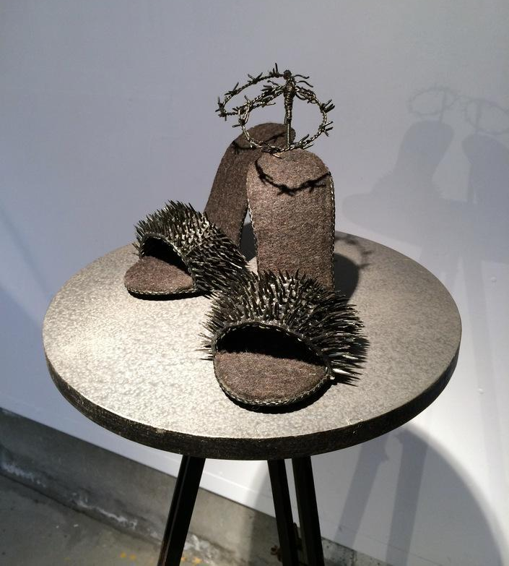
The inspiration to create Passages stemmed from a conversation that Rose had with psychiatric nurse who explained that women who are abused by their partner generally make seven attempts to escape from them; Rose pointed out that the realization was unsettling. (Rose Sellery Interview 2014) Later, the idea of seven attempts would be recreated as it’s own piece within Passages using seven suitcases and a performance video created by Sellery. In addition to the moment that inspired Rose to create the installation also comes the motivation that encompass some of the individual pieces within Passages, for example the complex ceramic, glass, and metal work shoes. To the left is a picture taken from Passages of one such creation, called Fatal Attraction, nd. These high-heeled shoes were made using steel, rubber, knife blades, wood, and paint to create an image of pain and also beauty. A person can only imagine the discomfort of having to wear such a shoe, and so as an audience member whether male or female, you are forced to think about the expectation of beauty women face each and every day. When asked in an interview about her influences, Rose gave the name of Gaza Bowen who creates very elaborate sculptural shoes which were on display in a show Rose had attended. “The political, feminist statements [Bowen] created in the form of shoes were an awakening to another world of art,” Rose says of the shoes. (Rose Sellery interview 2014) It is very easy to see the influence that Rose speaks of when you view one of the many shoe creations she has completed throughout the years. (Rosesellery. com)
One might be curious to discover how Sellery came to physically construct Passages, not just the ideas and experiences that she used as motivations behind it. It came as a surprise to learn that Rose had been introduced to the idea by none other than Susan Leask, then curator at Santa Cruz MAH and current art history teacher at California State University Monterey Bay. Leask provided an opportunity for Sellery to create a solo exhibition, and suggested to her that she create an installation, rather than go with the typical sculpture on pedestal approach. Because Sellery had already created the short movie called ‘Seven’ which was about the seven attempts to leave, she used this as the centerpiece for the rest of her sculptures and creations within the installation, each piece containing their own story. Something that is unique about the way that Rose creates the narrative is that it touches on abuse in a very neutral way rather than an aggressive accusation. This is how Passages, the story of a woman’s struggles and her ultimate happiness, was born.
Many people believe that a feminist artwork is simply art made by a woman, however this is not case. Feminist art can in fact be created by any sex, but it remains to be seen that feminist art produced by women contains an emotional connection and sincerity in its expression. A number of artists, for instance Judy Chicago, believe that feminist art is art that connects and validates a woman’s experiences, specifically the inequalities they face in the real world. In the 1960’s and 70’s ,the Feminist Art Movement goes largely unrecognized in history and yet marks a time of profound expression by female artists. A patriarchal society in which female creativity is overlooked is steadily changed by the women in the Feminist Art Movement who spoke outside of their assigned maternal silence. Sexuality, free expression, eroticism, and unseen perspectives are all part of the creation that artists like Judy Chicago and Rose Sellery have created. For Rose, her sculptures, jewelry, and installation provide the audience with new perspectives and experiences which draws you in and leaves you breathless.
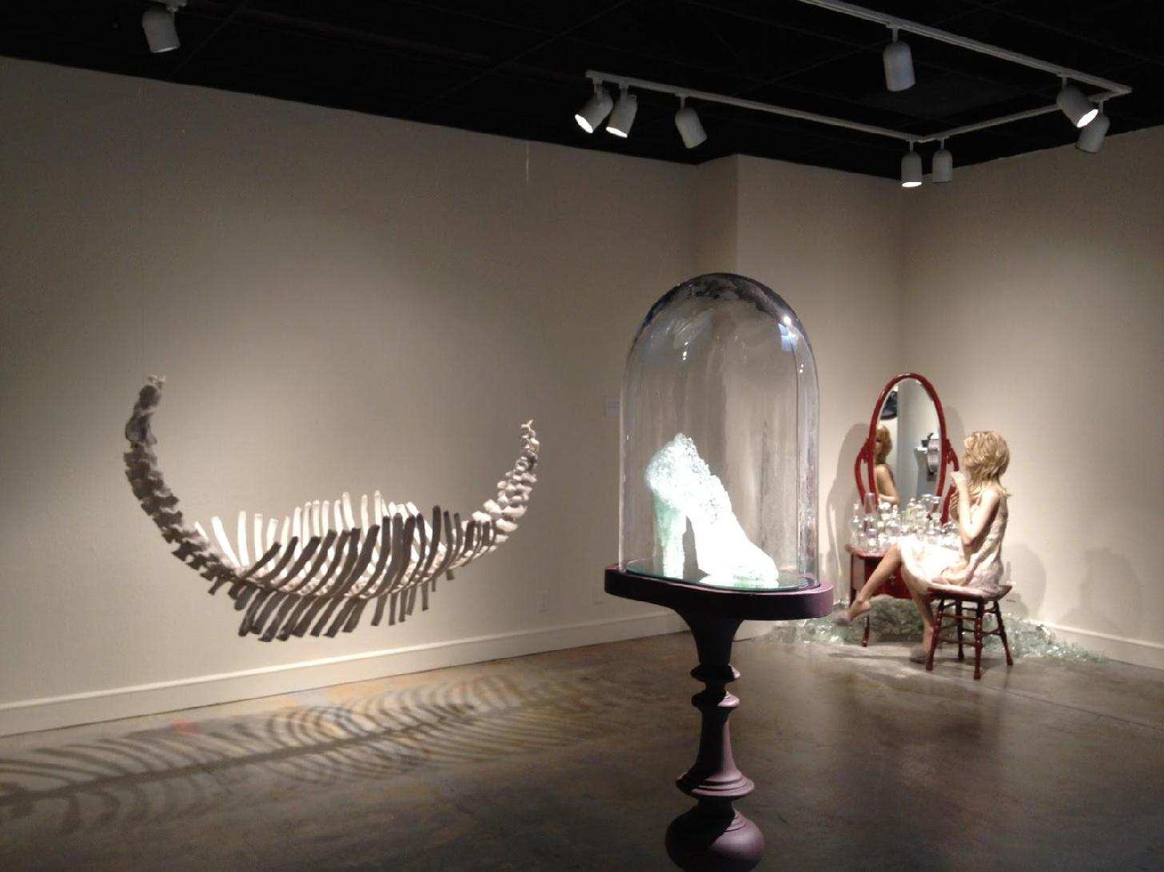

Annotated Bibliography:
Brodsky, J., & Olin, F. (2008). Stepping Out Of The Beaten Path: Reassessing The
Feminist Art Movement. Signs: Journal of Women in Culture and Society, 329-
342. Retrieved December 3, 2014, from
https://iwa.rutgers.edu/media/uploads/Signs_Article.pdf

The article Reassessing the Feminist Art Movement delves more into the impact the Feminist Movement had on post modernisms and how the movement really illustrated and awaked a new sexual freedom among women in that time. Much of the material included talks more about social issues among women, sexism, maternal instincts, and a lack of acknowledgement and recognition for budding female artists.

Chadwick, W. (1990). Women, art, and society. New York, N.Y.: Thames and Hudson.

Whitney Chadwick explains in depth the history of Feminist Art and the movement that began in the 1960’s. In addition, important women that were involved, where, and what they were doing to teach the acceptance of female inclusion in art is also discussed.

Chicago, Judy. (n.d.). What is Feminist Art? Retrieved December 5, 2014, from
http://www.judychicago.com/application/assets/pdf/what-is-feminist-art.pdf

In a self-published application regarding her art, Judy Chicago talks about what Feminist Art is to her, what symbols of a woman are present in her art, and how art created by women is experienced different by herself and her viewers.

Davies, H., & Art, S. (1997). Blurring the boundaries: Installation art, 1969-1996. San
Diego, Calif.: Museum of Contemporary Art, San Diego.

Davies provides a number of contemporary pieces of installation art ranging over the course of three decades. In addition, he also provides detailed explanations of how they were created, who created them, and what their possible interpretations art.

Desmond, K. (2011). Ideas about art. Chichester, West Sussex: Wiley-Blackwell.
Exhibitions: The Dinner Party by Judy Chicago. (n.d.). Retrieved December 6,
2014, from http://www.brooklynmuseum.org/exhibitions/dinner_party/

In this specific chapter from Ideas about art, Desmond talks about the installation completed by Judy Chicago called The Dinner Party in fine details.

Fuller, D., & Salvioni, D. (2002). Art, women, California 1950-2000: Parallels and
intersections. Berkeley: University of California Press.

In this book, two women named Fuller and Salvioni illustrate the complex history behind female produced art, as well as the history of the Feminist Art Movement . Within the chapters, important dates and artists are mentioned, as well as outstanding references to completed pieces in varying mediums.

Gerhard, J. (2013). . The Dinner Party, 2002 Judy Chicago and the Power of Popular
Feminism, 1970-2007. Athens, GA: The University of Georgia Press.

This is an in depth study and interpretation of The Dinner Party, an installation piece completed by Judy Chicago. Details of the components and perspectives of it’s creator(s) is also provided.

Reiss, J. (1999). From margin to center: The spaces of installation art. Cambridge, MA:
MIT Press.

Reiss explains how and why artists create installations rather than other types of media, and how they come to chose the details of their creative spaces.

Rose Sellery. (n.d.). Retrieved December 8, 2014, from
http://rosesellery.com/Rose/Rose_Sellery.html

Rose Sellery’s website provides a brief background, as well as examples of Sellery’s work categorized by media. In addition, each piece provides a small insert of information pertaining to the title, medium, and sometimes the date of creation.

Rose Sellery Interview (2014)

In an interview with Rose, myself and two other classmates asked her a series of
questions about her history as an artist, her influences, and the importance of
Feminist Art and the Feminist Art Movement were to her.

Tuana, N. (n.d.). The Speculum of Ignorance: The Women's Health Movement and
Epistemologies of Ignorance. Hypatia, 1-19. Retrieved December 6, 2014, from
http://www.jstor.org/stable/3810948

In Hypatia, the symbols and motifs of Feminist Art are talked about, as well as how art made by women differs from that created by men. Struggles pertaining to female acceptance in society and the patriarchal culture are also discussed.

