**Tattoos: Japanese and American Perceptions**

Shelby Lydon

California State University Monterey Bay

**Abstract**

Recently, tattoo culture has been on the rise in Western society: famous celebrities with tattoos are steadily increasing and fashion magazines exist to illustrate tattoo shops and artists. During the 1980’s and 90’s in America, tattoos started to became accepted as a trend of the next generation. In Japan, tattoos are seen as negative due to their strong association with Yakuza and are kept hidden in the shadows of organized crime and people with tattoos are considered as lower class citizens. Due to these negative associations, tattooed people in Japan are prohibited from entering most bathhouses, festivals, and are sometimes denied jobs. How do the individual countries perceive tattoos and what motivates them to get or not get a tattoo themselves? To study this, I conducted a survey of 45 Japanese and American citizens and analyzed their responses. Initially, I believed that American and Japanese perceptions would be quite different, American’s being more positive than Japanese, however overall they are the same. Both parties associate tattoos strongly with rebellion or crime; yet, there is a slightly positive perception which relates tattoos to fashion and creativity as well. In addition, factors such as future employment and societal judgment from friends or family largely prevent a person from getting tattoos in either country. While tattoos are obviously more prevalent in America, there remains the stigma of a negative image, and in Japan the same negative perception is seemingly more deeply rooted in the culture and therefore harder to overlook. Despite outside pressures and future consequences, Japanese people simply lack an interest in getting tattoos at all, whereas Americans are conclusively opposite.

**Introduction**

In America, tattoos are simply called tattoos; however, in Japan they can be called tattoos, ‘irezumi’, or by other names that integrate different Japanese kanji. In both countries, tattoos seem to be gradually growing in popularity within the respective societies. Yakuza, or Japanese organized crime members, are the largest tattoo demographic in Japan and have been for centuries. However, fashion tattoos are steadily increasing among younger generations. In America, tattoos are seen much more often in society than they are in Japan and so it is not considered out of the ordinary that tattoos are so popular and largely accepted. Both countries share a different opinion regarding tattoos, but one day I believe their perceptions may become the same.

**1. Significance of the Study**

I have tattoos and have been interested in them for many years. For one year, I studied abroad in Okayama, Japan and during that time I saw very few people with tattoos. In America, specifically California, tattoos are seen daily and in abundance, especially on younger people. The purpose of this study is to understand any cultural differences and similarities between Japan and America regarding the acceptance of “ink culture” and to identify as well as understand the motivations which compel someone to get or not get a tattoo.

**2. Research Questions**

1. How are tattoos perceived among Japanese and American youth?
2. What motivates college students and recent graduates to decide to get or decide not to get a tattoo in Japan and America?

**3. Research Background**

3.1 Tattoo History in the World

Tattooing in Ancient Egypt was generally confined to women (Vail, 2008). Centuries ago, tattoos were used similarly to war paint by some tribes in order to scare enemies away (DeMello, 2014). In addition, as early as 2160 BC tattoos were used as “magical” protection by some tribes of people (Vail, 2008). Around the 18th century, tattoos were used as a “rite of passage” by Maori tribe people and often identified social status (Gilbert, 2000). For instance, if you had no tattoos, you were of lower status (Pacific Islanders in Communication, 2003). Around the 1820’s, the collection of tattooed Maori tribesmen heads became a popular activity for hunters (Robley, 2012).

3.2 Tattoo History in Japan

In the early 1200’s, Japanese indigenous people called ‘Ainu’ bore facial tattoos, specifically around their mouths (アイヌ民族博物館). Four-hundred years later, during the Edo period[1], the Japanese novel called ‘Suikoden’ included images of tattooed warriors which had previously never been seen in literature. The Suikoden novel is based on the original Chinese text; however that did not have the same artwork. Tattoos were also used as a form of punishment to identify criminals during the Edo Period, different designs and locations displaying a man’s crime to society. Due to these tattoos, many people who bore penal tattoos were unable to get proper jobs, and instead were drawn to crime in order to survive (Kitamura, 2005). Ukiyoe（浮世絵）artists began tattooing ornate heroic scenes and mythological creatures etc., called ‘irezumi’（刺青）on willing participants (Sekiguchi, 2000). Later, Emperor Meiji[2] of the mid19th century forbade tattoos because he feared the barbaric image. The emperor did not want foreigner to see the tattoos and associate Japan with a ruthless or unwelcome brutality (Kitamura, 2005). During the 1870’s through the 1920’s, Japanese tattoo artists were allowed to tattoo foreigners but not native Japanese people (Gilbert, 2000).

3.3 Tattoo History in America

Circus and sideshows “freakshows” in late 19th Century began displaying tattooed people as attractions (Gilbert, 2000). In 1842, James F. O'Connell was first tattooed man exhibited in United States after being shipwrecked, followed by capture by New-Holland aborigines, and finally tattooed (O’Connell, 1845). In the 1940’s Japanese tattoo artist Kazuo Oguri (aka: Horihide) is introduced to Norman Collins “Sailor Jerry”, a famous tattoo artist in America. Sailor Jerry began tattooing sailors in Hawaii during and after WWII with many of his designs displaying a definite Japanese influence (Kitamura, 2001).

During the 1940’s through the 16’s, young “tough” teens and biker gangs received tattoos in unsanitary American tattoo shops in order to outwardly display their suggested masculinities (Gay, 2002; Vail, 2008; DeMello, 2000). Some years later, prison tattoos grew in popularity among crime members, much like penal tattoos and yakuza in Japan. Inmates would create hand-crafted tattoo equipment out of safety pins, sewing needles, and use pen or marker ink (Vail, 2008).

3.4 Tattoo adoption into Japanese and American societies

In Japan, criminals with tattoos began to add onto their existing tattoos, creating elaborate scenes with color in order to cover up the shame of their penalty. Eventually, many of those criminals created and became part of the Japanese Yakuza (Gay, 2002). After World War II, the Yakuza crime rate increased thus gangs grew, likewise the number of tattooed members increased as well (Goodman, 1992). However, tattoos in Japan still remained hidden underneath clothing at all times. Recently, the mayor of Osaka Toru Hashimoto conducted a survey among Osaka workplaces to identify people with tattoos (Japan Daily Press, 2012).

In America, a man named Jean Baptiste Cabri was the first tattooed man to become a carnival performer in 1804 (DeMello, 2014). During the next century, tattoos would continue to draw crowds to circuses and sideshows. During and after World War II, sailors and other military officers began receiving tattoos, most which were associated with their respective divisions; the style of tattoo done during that time are known as ‘Americana’ (Kitamura 2001, DeMello 2014). In the 1960’s there was a tattoo renaissance, quickly followed by the rise of punk culture in the 80’s which exhibited a rise in tattooed celebrities, specifically musicians.

3.5 Tattoo Statistics

In 1999, a famous tattoo Japanese artist named Horikazu claimed that 99% of his customers were affiliated with Yakuza, however in 2009 that number had decreased by half (Yamada, 2009). There was an estimated 102,000 known Yakuza members who had tattoos in 2007; it is unclear of the number today as that information is difficult to acquire. In 2012, the Osaka government surveyed public workers in order to identify those with tattoos; out of 34,000 employees, only 110 had tattoos, less than 1% (JDP, 2012). Those people who are found to have tattoos are often penalized with fines, loss of bonuses, vacation time, and even termination.

In America, however, 14% of the total U.S. population has at least one tattoo; as of 2013, the population was at 45 million people (Statistics Brain). According to Regina Corso, men are 15% more likely to get a tattoo versus women at 13% and 84% of people who have tattoos do not regret getting them (Corso, 2008). One-third of those without a tattoo (32% of the survey conducted by Harris Interactive) say people with tattoos are “more likely to do something most people would consider deviant” (Corso, 2008). In addition, women are better at accepting the pain tolerance associated with tattoos than men (Sanders, 2008).

**4. The Study**

4.1 Demographics

114 college students and recent graduates participated in this study. From Japan there were 45 people total, 20 men and 25 women. From America, the remaining 69 were made up of 23 men and 46 men. The majority of participants were women between the ages of 20 and 23.

4.2 Methodology

Online Japanese and American surveys completed anonymously by natives from each country.

**5. Results**

5.1 Research Question 1: How are tattoos perceived among Japanese and American youth?

Survey respondents were asked to use a 5-point scale to answer the following question, “In general, society in your country thinks of tattoos how?” On the scale, one represented very positive and five very negative.

**Graph 1: In society, how are tattoos perceived**

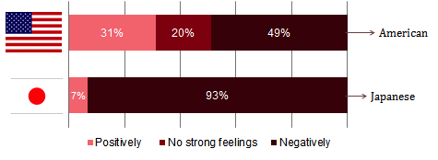

From graph 1, the data showed that the American perception of tattoos has a broader range of negative and positive whereas the Japanese perception is overwhelmingly negative.

The following question is “In your culture or society, people with tattoos are associated with what?”

**Graph 2: In society, what are tattoos associated with**

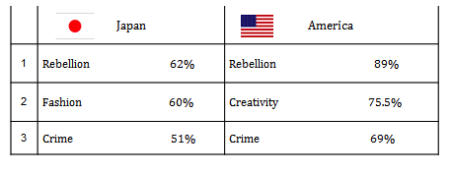

Both Japanese and American surveyors agreed that people with tattoos are mostly associated with rebellion, a negative image (Graph 2). The next question was slightly different, asking “You think that people with tattoos are considered what?” 60% of Japanese people considered tattooed people scary, where only 2% of Americans thought the same. Generally, both countries think slightly positively of tattooed people.

The next question asks what age-range people found was most appropriate for someone to get a tattoo. Surveyors were given the 6 choices, which are seen in ‘Graph 3’ below. Japanese and Americans agreed that anyone between the ages of 15 and 18 are too young to get tattoos, however both parties had 18 people which stated that any age range was most appropriate.

**Graph 3: Appropriate Age Range**

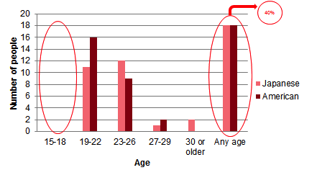

* 1. Research Question 1 Results Summary

Overall, the perceived response from Japanese people was overwhelmingly negative; however both cultures associate tattoos with rebellion more than anything. As for the perception of tattooed people, Japanese participants thought that people with tattoos were scary whereas only 2% of American surveyors agreed. In opposition, Americans thought tattooed people were moreinteresting than scary. Both parties also considered people with tattoos as adventurous. As for the age at which both countries said was appropriate, both Japanese and Americans said any age was appropriate for people to get tattoo’s, although no one claimed that the ’15-18’ age range was appropriate.

5.3 Research Question 2: What motivates college students and recent graduates to decide to get or decide not to get a tattoo in Japan and America?

**Graph 4: Do you have a tattoo?**

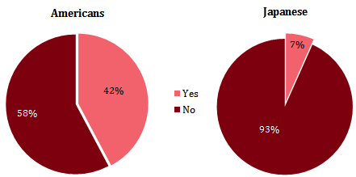

The next survey question was as follows, “Do you have any tattoos?” The reason why I asked this question is because I believed that the opinions of people with tattoos would vary greatly from those of people without tattoos. I wanted to find out if the results of the study reflected such a variance. The Americans who participated in the survey are almost equally tattooed people and non-tattooed people. On the other hand, the Japanese participants with tattoos were only 3 out of the 45, just 7% (Graph 4). Among the Japanese participants, the number of people with tattoos was obviously very few, which in turn made for an equal comparison between Americans somewhat difficult.

Next, outside famous people, how many men and women between the ages of 18 and 25 did the surveyors know who had tattoos? The purpose of this question was to conclude how often the individual participants came into direct contact with tattoos, which ultimately could affect their judgment and provide a larger variety of answers.

**Graph 5: How many tattooed people do you know?**

From the results shown in Graph 5, the data shows that Americans not only know more people with tattoos, but the number of tattoos those people have is much larger than Japanese people. In Japan, it is apparent that very few people with tattoos are seen in society. Additionally, the number of survey participants from Japan that claimed they knew zero people was 28% (Graph 5).

5.4 Why do people want or not want tattoos?

**Graph 6: Why do people not want tattoos?**

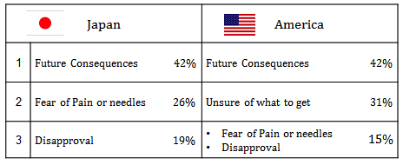

Those 26 Americans and 42 Japanese people without tattoos were asked to give a reason why they do not, and will not, have tattoos in the future. 42% of both Japanese and Americans without tattoos said it was due to a fear of future consequences, for instance getting a job. Americans are also more concerned with what to get in terms of tattoo design, rather than a fear of pain or needles associated with tattooing, which was the case for the Japanese participants (Graph 6).

The following survey result reflects an *overall* general reason why people tend not to get tattoos, not just the survey participants specifically. Japanese and Americans both agreed that future consequences are the main reason why people do not get tattoos. 60% of Japanese people and 91% of Americans shared that opinion. Japanese surveyors also showed a perception in regards to how their respective families might disapprove of their tattoos.

**Graph 7: Why do people want tattoos?**

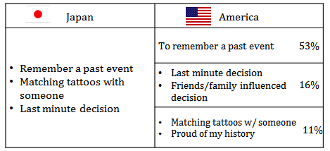

The 19 Americans and 3 Japanese people with tattoos were asked why they got their tattoo(s). Due to the fact that there were only 3 Japanese people with tattoos, each person provided a different reason for getting their tattoos. In opposition, the majority of Americans got tattoos to remember a past event, person, or pet (Graph 7).

The next survey question was, what most persuades someone (aged 18-25) to get a tattoo? The majority of Japanese and Americans stated that people get tattoos in order to remember a past event, person, pet, etc., This coincides with the same answers provided by those people with tattoos, shown in the graph above.

5.5 Visual Study

**Image 2: Americana style Ship**

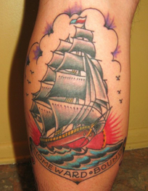

**Image 3: Ornate Chest piece**

**Image 1 Kanji Tattoo**

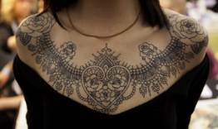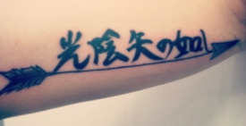

The pictures above were included in this study as a means to gauge the perceptions and opinions people had on specific tattoo designs. The first picture is of a Japanese Kanji tattoo, followed by a traditional Americana style ship, and lastly an ornate, calligraphy style chest piece. Each tattoo is on a different part of the body, in different colors, styles, and are displayed on people of different sexes. Surveyors were given a five-point scale to assess how much they liked or disliked the tattoo. In a comment section, they were asked to provide reasons why they felt the way they did.

**Graph 8: American Visual Study Results**



**Graph 9: Japanese Visual Study Results**



From graphs 9 and 10, Americans showed much more positive feedback regarding the example tattoos than the Japanese participants. Something that was interesting was that, in regards to ‘Image 1’ despite the fact that it was done in Japan, Japanese people seemed not to like it. This is one of my many tattoos. However, Americans showed an interest in tattoos in a foreign language.

5.6 Summary of Research Question 2

Both countries agreed that the main reason why people get tattoos is to remember a past event, person, pet, etc. Also, the main reason why people do **not** get tattoos is because they are afraid of future consequences. Participants from Japan and America both claim pressure from outside sources affects their decisions to get or not get tattoos, however the pressure in Japanese society seems to be greater than that of America. For instance, many Japanese people made comments like this one said by a Japanese man aged 23, “You should not hurt or damage the body that your parents gave you.”

5.7 Survey Participant Comments and Quotes

Many different opinions were provided by participants in the final surveys, however only those most important are included in this paper. “I was surprised to see many tattoos when I was an **exchange student in America**. I think the culture is very different, but I was able to accept [tattoos]”, said by a Japanese man, age 22. Another Japanese student said “Tattoos are discriminated against in Japan because of the image of Yakuza.”

Americans also provided interesting quotations, for instance, “I feel like tattoos in the work place should be widely accepted,” and “Two people can get the same tattoo, but I might appreciate one person over the other based on [the] reason for getting them.” In both countries, it seems that the negative image of tattoos still exists; however, I think people want that image to change.

**6. Conclusion**

The data shows that there far more Americans with tattoos than Japanese, something that is not necessarily surprising. People without tattoos say it is largely due to a fear of future consequences, and or, a fear of the pain or needles associated with tattoos. In both countries, societies share the negative perception of tattoos, associating them and those people with tattoos with rebellion and crime. In addition, both countries also suggested that age was irrelevant when getting a tattoo, although the data showed a slight irregularity; most surveyors said age was unimportant, but no surveys could say for sure that the age range 15-18 was appropriate.

On top of that, Japanese people seem to be more afraid of those people with tattoos than Americans, whereas Americans think people with tattoos are more interesting. Overall, both countries said the reason why people get tattoos is to remember a past event, person, pet, etc.. And the main reason why people do not get tattoos is attributed to the fear of future consequences like not being hired for a job.

From this study, it seems that people are aware of the negative perceptions of tattoos in Japan and America, however that perception seems to be changing among younger generations. Nevertheless, the negative image associated with tattoos continues to be difficult to erase completely.

**7. Limitations of the Study Points and Future Studies**

Within the study, there were very few Japanese people with tattoos and the majority of Japanese participants came from Okayama Prefecture. Also, I had more Americans take the survey than Japanese people limiting the possible variations of outcomes.

In regards to future studies, I want to provide more in depth visual studies with more examples in addition to conducting more face-to-face interviews. Furthermore, including a larger age-range for participants will provide a more diverse demographic for study. Finally, if I have the opportunity, I want to interview tattoo artists in Japan and America.

**8. Bibliography**

Atkinson, M. *The sociogenesis of a body art.* Canada 1971: Toronto Press.

Corso, R. (2008). The Harris Poll, Harris Interactive.

[http://](http://www.harrisinteractive.com/vault/Harris-Interactive-Poll-Research-Three-in-Ten-Americans-with-a-Tattoo-Say-Having-One-Makes-Them-Feel-Sexier-2008-02.pdf)[www.harrisinteractive.com/vault/Harris-Interactive-Poll-Research-Three-in-Ten- Americans-with-a-Tattoo-Say-Having-One-Makes-Them-Feel-Sexier-2008-02.pdf](http://www.harrisinteractive.com/vault/Harris-Interactive-Poll-Research-Three-in-Ten-%20%20%09Americans-with-a-Tattoo-Say-Having-One-Makes-Them-Feel-Sexier-2008-02.pdf)

DeMello, M. (2000). *Bodies of Inscription.* Duke University Press.

DeMello, M. (2014*) Inked: Tattoos and body art around the world.* ABC-CLIO.

Fischer, L. (1998*). Irezumi: Tattoo, taboo, and the female body.* Post Script:Essays in Film and the Humanities, 18(1), 11-23.

Gay, K. (2002). *Body marks: tattooing, piercing, and scarification.* Brookfield: Millbrook Press.

Gilbert, S. (2000). *Tattoo history: A source book: An anthology of historical records of tattooing throughout the world*. New York: Juno Books

Goodman, R. (1992). *Ideology and practice in modern japan.* New York, NY: Nissan Institute.

Kato, Y. (2012) *Japan Daily Press.*

<http://japandailypress.com/?s=Tattoos>

Kitamura, T. (2001*) Bushido: Legacies of the Japanese Tattoo.* Atgen Pennsylvania: Schiffer Publishing Unlimited.

O’Connell, J. (1846). *The Life and Adventures of James F. O'Connell, The Tattooed Man. Providence: J.F. Moore, Printer.*

Sekiguchi, T. (2005) *Horiyoshi iii yokohama, Japan.* Time International, The Best of Asia, 60-59

Vail, D. A. (2008).*Customizing the body: The art and culture of tattooing.* Philadelphia: Temple University Press.

Yamada, M. (2009) *Westernization and Cultural Resistance of Tattooing Practices in Contemporary Japan.* Indiana University.

<http://opus.ipfw.edu/cgi/viewcontent.cgi?article=1006&context=sociol_facpubs>

アイヌ民族博物館

<http://www.ainu-museum.or.jp/index.html>

日高, 旺著. (2005). 黒潮の文化誌. 鹿児島: 南方新社.

1. Edo period lasted from the year 1603 until 1868
2. Meiji period lasted from the year 1868 until 1912